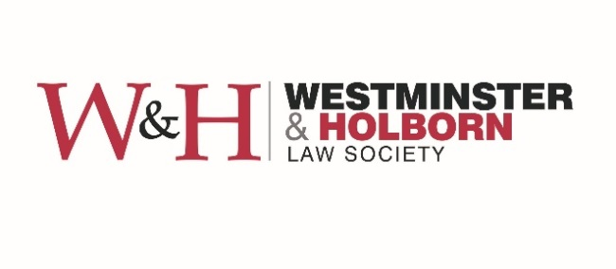

NQ Award – Rising Star 2020

C Applicant Name:

Job Title:

Nam Name of Company:

Job title:

Email:

Telephone:

Address:

Confirmation that Applicant is a member of WHLS:

Nominator’s Name (if different):

Job title:

Email:

Telephone:

Name of company:

Address:

The 'WHLS NQ Award – Rising Star 2020' celebrates the inspirational achievements and hard work of trainee solicitors due to qualify in 2020.

Our panel of judges, comprising esteemed solicitors renowned in their respective fields, are now inviting nominations for the Award. The judges are looking for trainees who have demonstrated an exceptional standard of work in addition to superlative dedication to the role of being a trainee. The judges are looking for trainees who are both excelling in their role and also in their wider commitment to their firm or to the wider legal community.

The judges invite nominations for any trainees who have excelled during their training contract but who have, in particular, demonstrated excellence in the following areas:

- Setting up a new or creative initiative for the firm;
- Exceptional commitment to pro-bono activities;
- Exceptional work in relation to writing topical legal insight / internal or external legal publications;
- Excellence in marketing their firm;
- Excellent in promoting awareness of e.g. mental health awareness or lawtech within their firms;
- Working on any particularly interesting or ground-breaking areas of law;
- Exceptional commitment to their profession during the circumstances of COVID-19, e.g. setting up new initiatives within their firm relating to COVID-19;
- Quality of work carried out to date;
- Outstanding teamwork skills and communication skills.

Please now attach your nomination in no more than 500 words (+/- 10%). Please be aware that our judges will only receive the reasons for nominations during the judging stage.

Entries can be submitted for yourself or for your colleagues. Please submit all nominations to cwhlawsoc@gmail.com by Friday 18 September 2020. Interviews will be held remotely during the week beginning Monday 21 September 2020.

For enquiries regarding your submission please contact Carolina Marín Pedreño, President of the Westminster and Holborn Law Society, at cwhlawsoc@gmail.com.

NOMINATION:

Word count:

